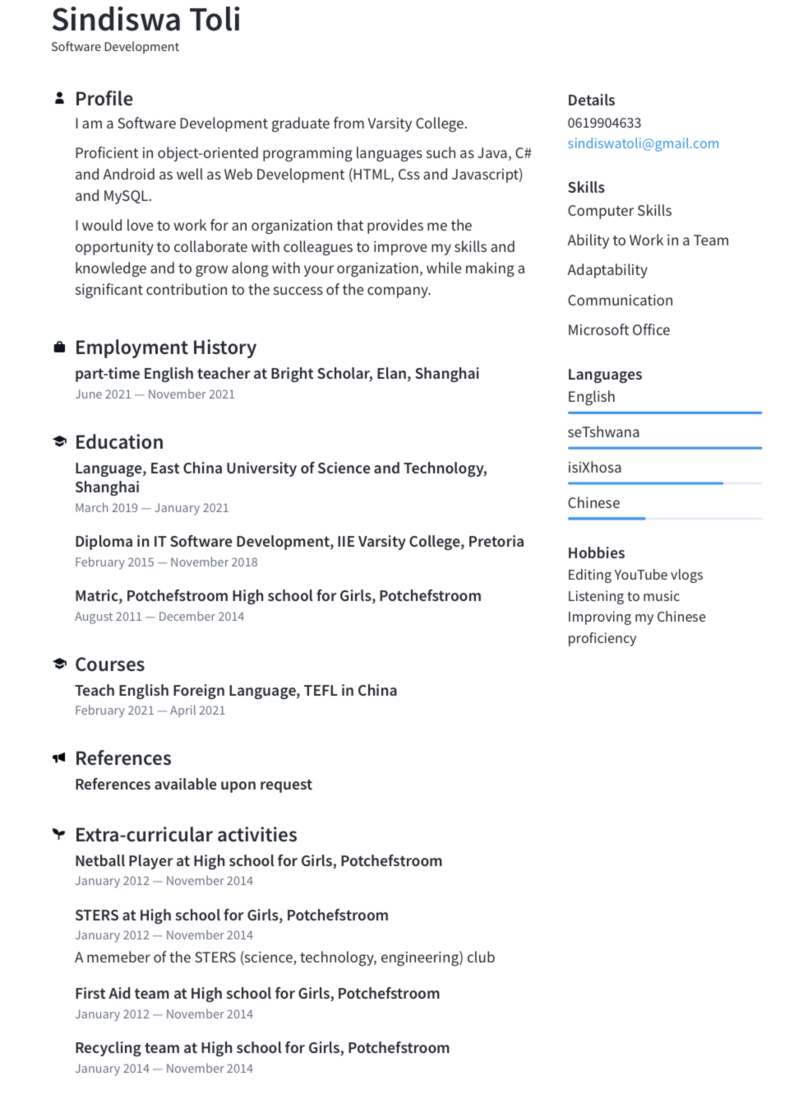

**Online Portfolio website**: Sindiswat/github.io/portfolio